I N T E R C U L T U R A L I N S T I T U T E

CULTURAL CONSIDERATIONS & CULTURALLY INFORMED PRACTICES TRAINING

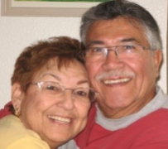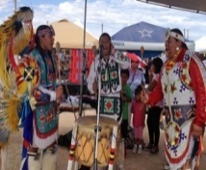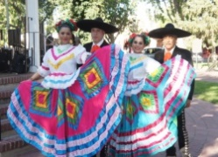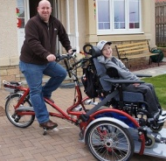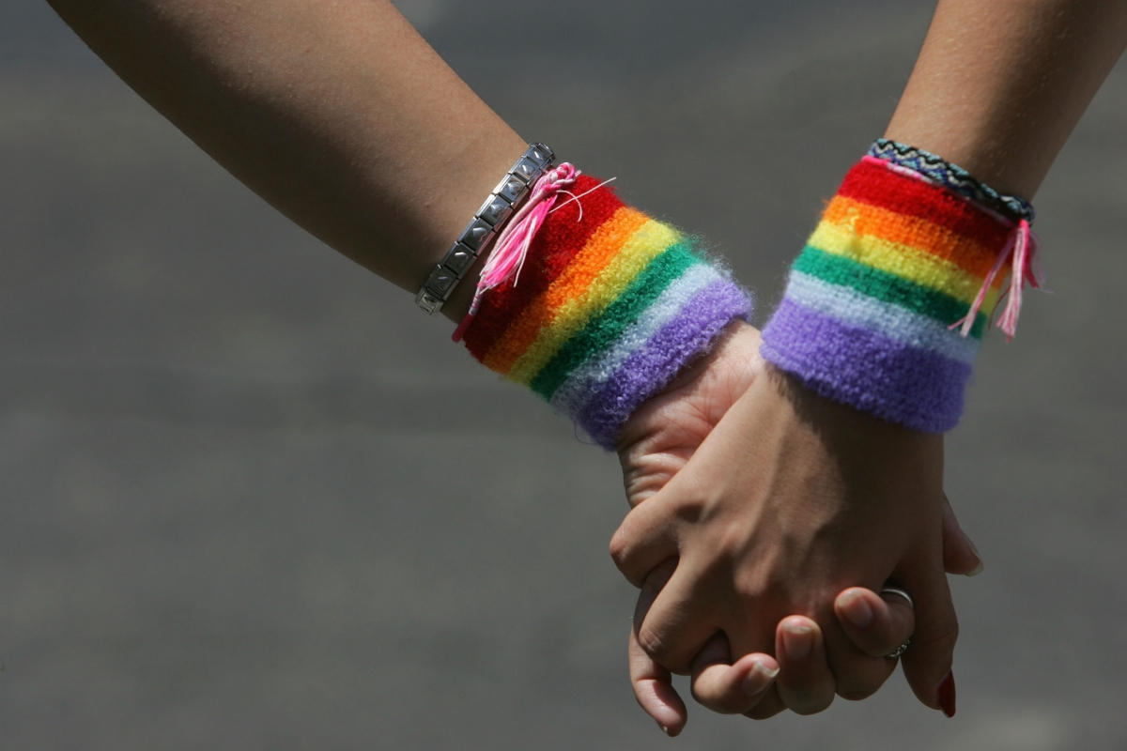

MEETS NEW MEXICO BOARD OF SOCIAL WORK EXAMINERS
CONTINUING EDUCATION COURSE REQUIREMENT ON NEW MEXICO CULTURES

TRAINING OBJECTIVES: Gain knowledge of cultural & linguistic considerations, demographics & disparities in New Mexico. Learn effective practices and approaches in serving the diverse populations of New Mexico. Complete a cultural & linguistic self-assessment (in-person only). Identify cultural characteristics found in New Mexico.

TRAINER: Fredrick Sandoval, MPA, Intercultural Institute, Cultural & Linguistic Competency Trainer
----------------------------------------------------------------------------------------------------------------------

Registration Instructions:
OPTION ONE: THREE (3) HOUR ONLINE COURSE ON NEW MEXICO CULTURES. To register, go to www.interculturalinstitutenm.com

Click on the Menu, click on the New Mexico Cultures Course page then click on the information box. It will take you to the page with information on the instructor, the payment box and the learning modules. Scroll down to and click on the $75 Registration fee box. You will be directed to the payment page. Please complete all the information, click the terms and conditions box then click on “Buy Now”. This will take you to the learning modules. It is available 24/7. You will need to score 70% or higher on the test to obtain a certificate of completion. You have 3 weeks from the time of enrollment to complete the course. A $25 reinstatement fee will be charged after the 3 weeks has expired.

⬧ OPTION TWO: SIX (6) HOUR IN-PERSON
COURSE ON NEW MEXICO CULTURES
To register please complete the 6 hour in-person registration form and email it to:

intercultural.institute@gmail.com

After emailing the completed form, please send a hard copy along with your form of payment in the amount of $125 to: Rachel Sandoval, 6555 Robin, Cochiti Lake, NM 87083

DEADLINE: Please submit Payment and Registration no later than ONE WEEK before the scheduled training session. A late fee of $25 will be charged if registering after the deadline.

For more information contact Rachel Sandoval at intercultural.institute@gmail.com , text/voice at 505.660.0373 or visit www.interculturalinstitutenm.com
OPTION TWO REGISTRATION FORM

SIX (6) HOUR IN-PERSON TRAINING
ON NEW MEXICO CULTURES

¹Training is held at the Hawthorn Inn, 1511 Gibson Blvd SE, Albuquerque, NM 87106 from 8:30am-4:00pm on the 2nd Saturday of the months below. Please indicate the date you are attending:

2020: ☐ February 8th ☐ May 9th ☐ June 13th
☐ November 14th

PLEASE PRINT

NAME (As you would like it to appear on your Certificate)
_______________________________________________

MAILING ADDRESS:

_________________________________________________

EMAIL ADDRESS:
_________________________________________________

TELEPHONE #____________________________

Best way to reach you: ☐ Email ☐Text ☐ Phone Call

OPTION TWO 6 HOUR IN-PERSON TRAINING FEES: $125
CHECK ONE (All levels of licensure: provisional, independent, clinical, masters and/or bachelors level, government, community provider & self-employed, private, for-profit and non-profit)
☐ SOCIAL WORKERS ☐ COUNSELORS, THERAPISTS
☐ PEER SPECIALIST* ☐ SOCIAL WORK STUDENTS*

*Reduced fee of $60. Please send a copy of school ID information and/or CPSW credentials with registration. Thank you.

¹Seating is limited.

